Dubai, 13th July 2026

Recipient: To Whom It May Concern

COMMERCIAL OFFER

Subject: Offer for titanium ingots

Dear Sirs,

We operate in commodity trading and wholesale supply of industrial products. We hereby offer titanium ingots to interested buyers as indicated below. The country of destination, logistics route, receiving point and applicable Incoterms are open for discussion and shall be agreed by the parties in the final transaction documents.
Offered product
Trial lot of titanium ingots, grades VT1-0 and VT1-0gr, circular section:

No. | Grade | Shape | Mass | Diameter | Length | Certificate
1 | VT1-0 | Circular-section ingot | 7,086 kg  (7.086 MT) | 730 mm | 3,748 mm | MTC No. 714  28.02.2000
2 | VT1-0gr | Circular-section ingot | 1,636 kg  (1.636 MT) | 555 mm | 1,500 mm | MTC No. 1049  17.04.2000

Commercial terms
Price: to be agreed upon
Delivery basis: Destination country, logistics route, receiving point and applicable Incoterms to be discussed and agreed with the buyer.
Validity: 7 calendar days, subject to prior sale and availability verification.
Final terms: Payment terms, exact Incoterms, inspection procedure, document set, export/import compliance and shipment plan shall be agreed in the supply contract.

Attachments included
Representative product photos and visible markings; MTC / acceptance test certificates No. 714 and No. 1049;
Inventory reference photo and summary for preliminary technical evaluation.

This offer is issued for preliminary commercial and technical review only. Any transaction remains subject to availability confirmation, buyer and seller KYC, sanctions and export/import compliance, inspection, payment route approval and execution of final written transaction documents.

Best regards,
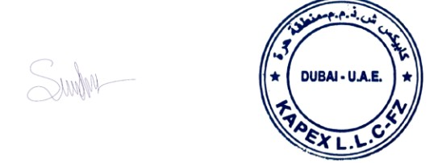
Aleksandrs Sirotkins Director
KAPEX L.L.C-FZ

KAPEX L.L.C-FZ | Dubai - U.A.E.

INVENTORY REFERENCE

The inventory summary below is included as a reference for potential additional volumes after the trial lot. All lots, weights, markings and certificates shall be reconciled and verified during inspection before contract signing or shipment.

Inventory summary reference: 3,467.75 metric tons / 1,185 ingots

No. | Product | Grade | Qty, MT | Diameter min / max (mm) | Avg diameter (mm) | Length min / max (mm) | Avg length (mm) | Weight min / max (MT) | Avg weight (MT) | Estimated ingot qty, pcs
1 | Titanium | VT1-0 | 1,352.94 | 700-750 | 725 | 2,600-3,500 | 3,050 | 5-7 | 6 | 225
2 | Titanium | VT1-0gr | 847.25 | 550-570 | 560 | 1,300-1,500 | 1,400 | 1.5-1.6 | 1.55 | 546
3 | Titanium | VT1-0k | 123.02 | 720-750 | 735 | 1,600-1,900 | 1,750 | 3.2-4 | 3.6 | 34
4 | Titanium | VT1-0lgr | 258.72 | 550-570 | 560 | 1,600-1,700 | 1,650 | 1.5-1.7 | 1.6 | 161
5 | Titanium | VT1-0tr | 232.02 | 730-750 | 740 | 1,700-2,000 | 1,850 | 3.4-4 | 3.7 | 62
6 | Titanium | VT1-0l | 653.80 | 560-740 | 650 | 1,500-3,500 | 2,500 | 1.6-6.7 | 4.15 | 157
Total, MT |  |  | 3,467.75 |  |  |  |  |  | Total, pcs | 1,185

Not part of the trial lot price unless separately agreed by the parties.

