ARMOURED MOBILE SHELTER

The ARMOURED MOBILE SHELTER is an innovative solution designed to ensure the safety of military personnel with the capability for firing and observation.
The shelter has been tested according to all norms and standards, certified, codified according to NATO standards. The SHELTER is dedicated to preserving life and health in combat conditions.

During the testing of THE SHELTER, it exceeded expected results, demonstrating resilience to:
- damage from all types of small arms (including 14.5 mm armor-piercing incendiary rounds from a grenade launcher);
- damage by 152 mm high explosive artillery shells (direct hit);
- landmine impact 120mm (direct hit, simultaneous detonation of two mines);
- attacks by all types of drones;
- cumulative means of destruction (RPG-7, etc.);
- damage by debris and blast waves;
- mechanical damage (for example, during transportation);
- effects of changes in ambient temperature;
- weather changes (rainfall of at least 2000 liters for at least 5 minutes).

Designed for frontline troops, it features a 3.3-ton steel dome that assembles in about 45 minutes to protect up to 10 soldiers from artillery, drones, and rocket grenades.

KEY SPECIFICATIONS & FEATURES
- Armor & Materials: Constructed with 16-mm to 20-mm armoured steel panels that can be bolted together and partially buried or covered with earth for camouflage.
- Defensive Mechanisms: Features a perimeter metal fence designed to detonate rocket-propelled grenades (RPGs) before they strike the main armour.
- Combat Utility: Includes hinged doors that allow troops to conduct reconnaissance or return sniper fire directly from the shelter.
- Mobility: The structure is fully transportable and can be dismantled, relocated, or rapidly disassembled from the inside.
The design is built to NATO specifications

TECHNICAL SPECIFICATIONS
Product weight: 3,300 kg.
Assembled dimensions (LxWxH): 3250 x 3250 x 900
Shelter assembly time: 45 minutes, disassembly time: 15 minutes Shelter material: 16mm thick armored steel

The shelter can be disassembled in 15 minutes, after which it can be transported in its disassembled form, for example, using a vehicle. The optimal dimensions of THE SHELTER allow it to be placed in its assembled form on a truck (using a crane) and transported to the required location for installation.

LATEST DVELOPMENT ON THE SHELTER INCLUDE:

- An arrangement of the trench under the bunker using a steel sheet with attached folding seats for personnel, instead of wooden stakes.

- Installation of an insulating, sound-absorbing, heat-resistant (up to 2000 degrees Celsius), moisture-resistant blanket between the layers of plates.

- Installation of a camouflaged anti-drone metal net above the Shelter system.

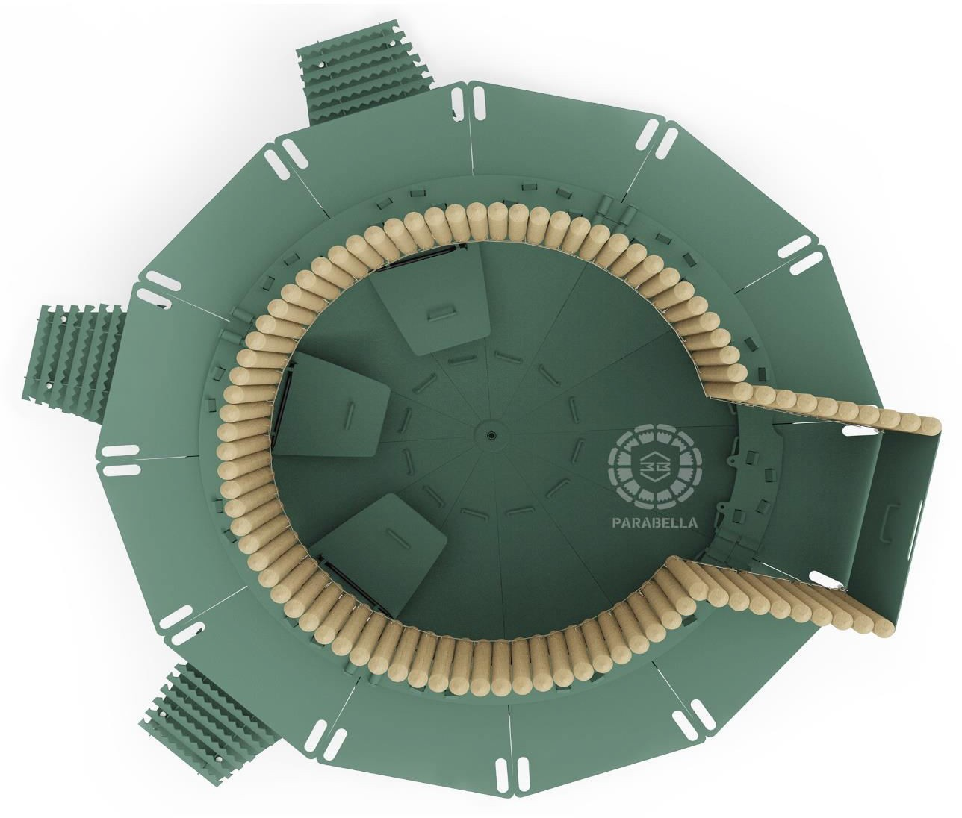

INSIDE VIEW

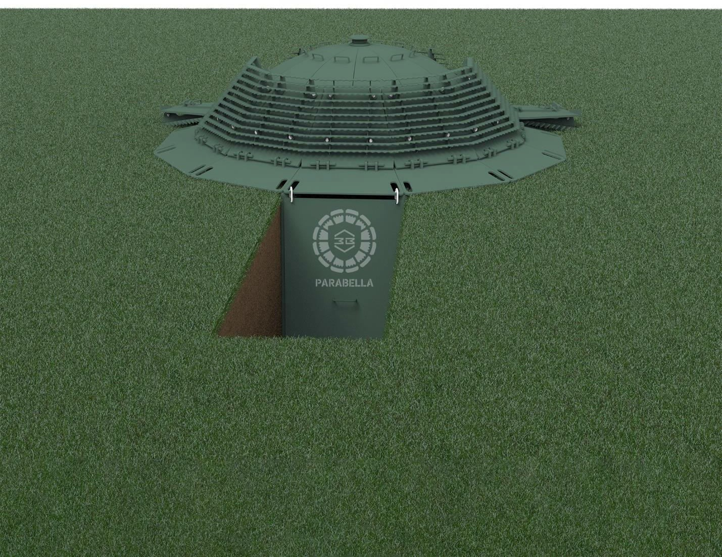

AFTER SETUP VIEW

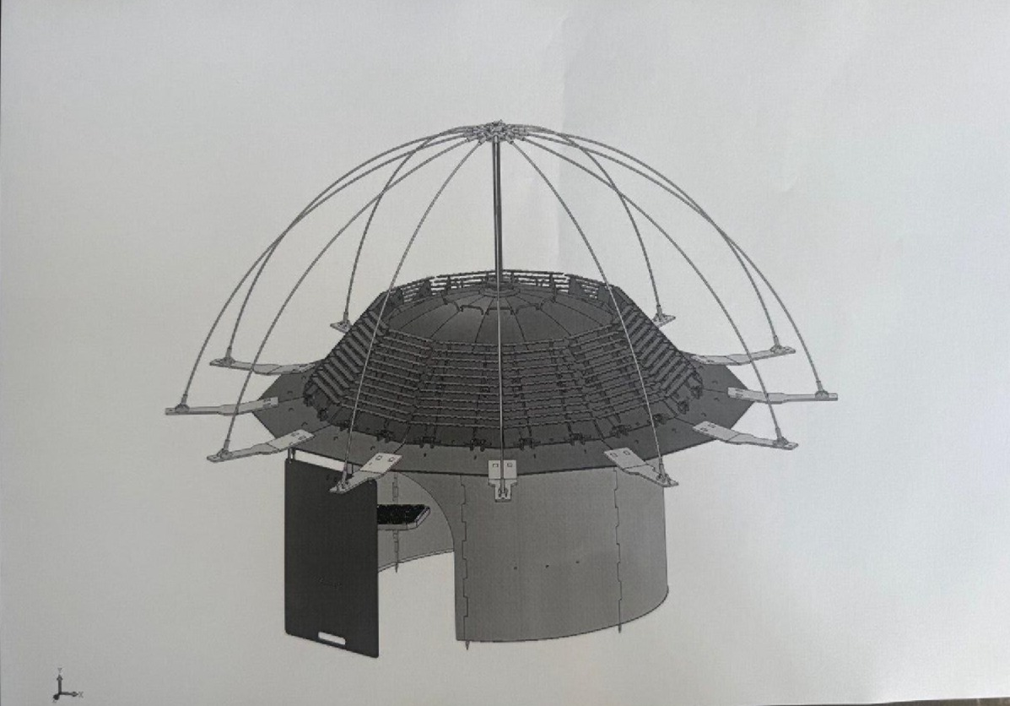

ANTI DRONE SETUP

