Super Silent 2250 kVA Genset
Rental Version:
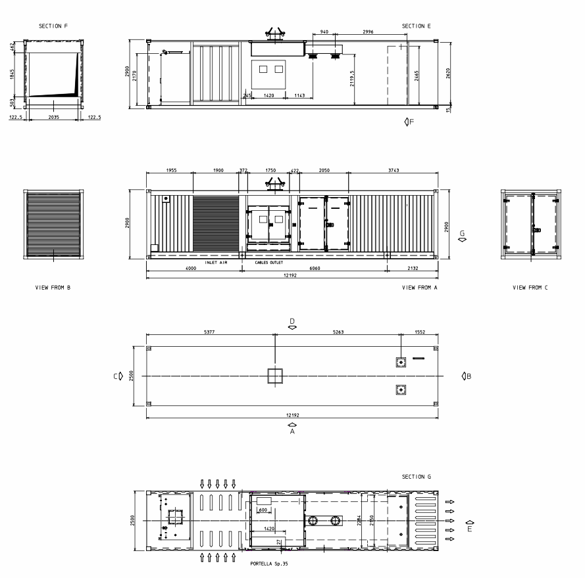

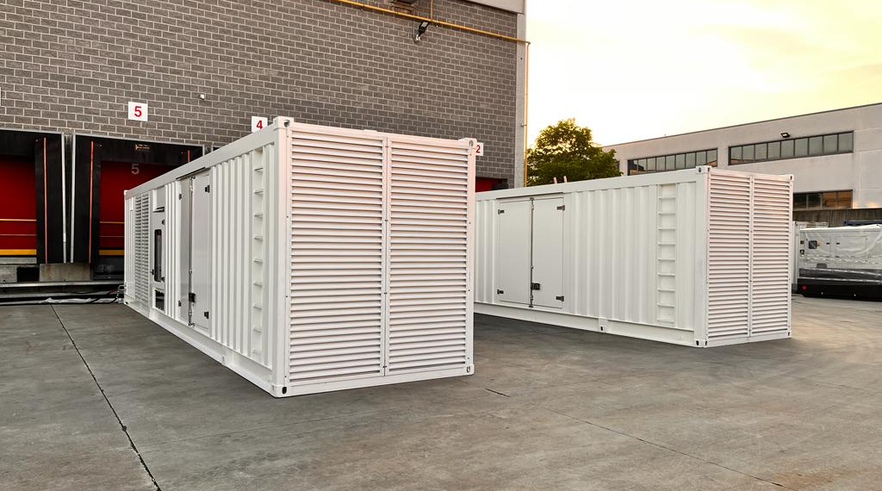
Container:
3 off purpose built Super Silent containers to accommodate MTU16V4000G63 open set generators.
The Containers are acoustically designed with Standard High Cube Container Dimension and inclusive Sound Attenuators. 2 Right Hand and 1 Left Hand Container.
Dimensions: Container Dimension with Exhaust: 12192mm (L) x 2500mm (W) x 3050mm (H)
Weight 26.600kg (With Empty Fuel Tank)
Color: Container RAL 9010 White
Fuel Tank: Capacity of 4600 Liter
Noise: 81dB(A) @ 7m +/-3 dB(A)

Genset:
Genset built with MTU 16V4000G63. Rated at 2250kVA .
Mecc Alte ECO 46-2L/4 alternator, oil primer and centrifuge fitted as confirmed by MTU, set mounted 4000A 4P motorised breaker and Starpoint Breaker for open Starpoint Operations, Set mounted radiator 25 degree Ambient temp
Open Skid Generators installed within purpose built acoustic containers.
Voltage: 400V 3Ph 50Hz or 60Hz(with 50Hz Auxilliary Supply for Electrical FAN)
Engine: MTU 16V4000G63
Speed: 1500/1800rpm
Control: DEIF AGC4-MK2
Engine Gov: ADEC
Alternator: Mecc Alte ECO46 2L/4A with MAUX excitation
Radiator: Tecno Group TG00094AA 30m3/s reduced airflow radiator with electric powered cooling fan for 25 Degree Ambient Temp.
Circuit Breaker: 4 Pole 4000A Schneider model NW04 motorised H2 100kA breaking capacity with Micrologic 6.0A trip unit .
Preheating: Thermostatically controlled 9kW 400V 3 phase water jacket heater with circulating pump
Auxiliary Dev: Deif 10A intelligent mains battery charger
Automatic Electric Pre-lubricating Pump
Set mounted 2000A neutral earthing contactor with CT
Fuel return cooler
Centrifugal oil filter (MTU)
Primary water separator filter

